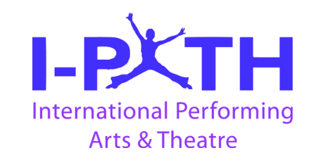
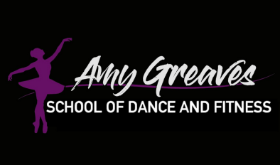
AGSOD Achievement Awards Information

The next term we are focusing on Achievement Awards with the i-PATH exam board. The achievement awards are great because:
- Motivation to Meet Targets: The achievement awards with the i-PATH exam syllabus serve as a fun and motivating platform for children to set and achieve dance-related targets. This not only enhances their skills but also fosters a sense of accomplishment.
- Learning New Techniques: The awards focus on encouraging children to learn new dance techniques. By participating in the i-PATH exam syllabus, they have the opportunity to broaden their dance skills and showcase their newfound abilities during the awards.
- Professional Evaluation: Each child's performance is assessed by a professional dance examiner, ensuring a fair and accurate evaluation. This adds a level of credibility to the awards and provides valuable insights into the child's dance proficiency.
- Personalized Feedback: The awards come with a detailed report containing personalized feedback. This feedback not only acknowledges the child's strengths but also provides constructive insights on areas for improvement, fostering continuous growth and development.
- Tangible Recognition: Children receive tangible rewards in the form of certificates and medals or trophies. These physical symbols of achievement not only boost their confidence but also serve as lasting reminders of their dedication and hard work.
Important Information:
- Event Timing: The dates and times for the awards are below.
- Detailed Schedule: Approximately four weeks before the exams, participants will receive the exact timing of their individual awards, ensuring a well-organized and smooth experience for all involved.
Participating in these achievement awards not only enhances the children's dance skills but also provides a holistic and rewarding experience that contributes to their overall personal development.
I presume all dancers are participating in the awards unless you notify me. Please let me know ASAP if your child is opting out of the awards, as this affects the timetable, other dancers and paperwork.

Payment
  - March exam fees will be due on Sunday 18th February and will be added to February dance fee invoices.
  - May award fees will be due on Sunday 7th April and will be added to April dance fee invoices.
  - Exam fees are non refundable.

Diddy
DANCE STYLE | NAME OF AWARD | DETAILS OF AWARD | COST | WHAT TO WEAR? | DATE OF EXAM VENUE
Diddy Ballet & Tap | Bronze or Silver Rosette (Classical) | One routine required | £23 | Purple leotard with attached skirt, white ballet socks, pink ballet shoes, hair classical ballet bun. | Sun 17th March AM  Hopwood
Diddy Commercial | Bronze or Silver Rosette  (Urban Dance) | One routine required | £23 | Black AGSOD t-shirt, black leggings, joggers or shorts, black jazz shoes, hair classical ballet bun. | Sun 19th May  AM  Hopwood
Diddy Acro and Cheer | Bronze or Silver Rosette  (Alternative Da) | One routine required | £23 | Black AGSOD t-shirt, black leggings, joggers or shorts, black jazz shoes, hair classical ballet bun. Pom poms and mat. | Sun 19th May  AM  Hopwood

Juniors
DANCE STYLE | NAME OF AWARD | DETAILS OF AWARD | COST | WHAT TO WEAR? | DATE OF EXAM
Junior Tap & Ballet (Classical) | Bronze or Silver star  (Classical) | One routine required | £27 | Black AGSOD tshirt, black leggings, pink ballet shoes, hair classical ballet bun. | Sun 17th March AM  Hopwood
Junior Commercial | Bronze or Silver Star  (Urban) | One routine required | £27 | Black AGSOD tshirt, black leggings, black jazz shoes, hair classical ballet bun. | Sun 19th May  AM - Hopwood
Junior Acro and Cheer | Bronze or Silver Star  (Alternative Da) | One routine required | £27 | Black AGSOD tshirt, black leggings, black jazz shoes, hair classical ballet bun. Pom poms & mat. | Sun 19th May  AM - Hopwood
Junior Contempoary | Bronze or Silver Star  (Classical) | One routine required | £27 | Black AGSOD tshirt, black leggings, bare feet, hair classical ballet bun. | Sun 17th March AM - Hopwood

Seniors

DANCE STYLE | NAME OF AWARD | DETAILS OF AWARD | COST | WHAT TO WEAR? | DATE OF EXAM
Senior Contemporary | Shield 1 or 2  (Classical) | Two routines | £39 | Black AGSOD tshirt, black leggings, bare feet, hair classical ballet bun. | Sun 17th March AM  Hopwood
Senior Tap | Shield 1 or 2  (Theatre) | Two routines | £39 | Black AGSOD tshirt, black leggings, black tap shoes, hair classical ballet bun. | Sun 17th March AM  Hopwood
Senior Ballet | Shield 1 or 2  (Classical) | Two routines | £39 | Black AGSOD tshirt, black leggings, pink ballet shoes, hair classical ballet bun. | Sun 17th March AM  Hopwood
Senior Commercial | Shield 1 or 2  (Urban) | Two routines | £39 | Black AGSOD tshirt, black leggings, black jazz shoes, hair classical ballet bun. | Sun 19th May  AM  Hopwood
Senior Musical Theatre | Shield 1 or 2  (Musical Theatre) | Two routines | £39 | Black AGSOD tshirt, black leggings, black jazz shoes shoes, hair classical ballet bun. | Sun 19th May  AM  Hopwood
Senior Acro and Cheer | Shield 1 or 2  (Alternative Dance) | Two routines | £39 | Black AGSOD tshirt, black leggings, black jazz shoes, hair classical ballet bun. Pom poms & mat. | Sun 19th May  AM  Hopwood

Advanced and Open classes

DANCE STYLE | NAME OF AWARD | DETAILS OF AWARD | COST | WHAT TO WEAR? | DATE OF EXAM
Rock n Roll and Latin | Shield one  (Partner dance) | Two routines | £39 | Black AGSOD tshirt, black leggings, black jazz shoes, hair classical ballet bun. | Sun 17th March AM  Hopwood
Ballet | Statuette 1  Founders  (Classical) | Three routines | £42  £48 | Black AGSOD tshirt, black leggings, pink ballet shoes, hair classical ballet bun. | Sun 19th May  Hopwood
Tap | Statuette 1  Founders  (Theatre) | Three routines | £42  £48 | Black AGSOD tshirt, black leggings, black tap shoes, hair classical ballet bun. | Sun 19th May  Hopwood
Advanced Dance | Statuette 1  Founders  (Theatre) | Three routines | £42  £48 | Black AGSOD tshirt, black leggings, black jazz shoes, hair classical ballet bun. | Sun 19TH May  AM  Hopwood

Any questions please do not hesitate to ask,
Best wishes Amy

