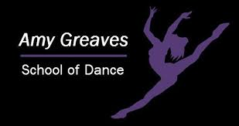 |  | 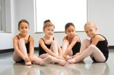

NEWSLETTER
OCTOBER 2020
INSIDE THIS ISSUE  PG. 2  Term Dates, Uniform Orders, Next Half Term and Booking Classes  PG. 3  Halloween, Filming, Celebration Week, Thank You |  | “Great dancers are great because of their passion.”

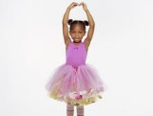 |  | Returning Back  Everyone has worked really hard in class and settled back into lessons really well. It is lovely to see everyone learning new choreography and making excellent progress. Keep it up dancers!
Term Dates & Uniform Order  There are no classes from Mon 26th Oct – Sat 31st Oct due to half term. Autumn term 2 runs from Mon 2nd Nov – Sat 12th Dec. The next uniform order will be on Saturday 7th Nov. Please email your orders to agsoduniformorder@outlook.com |  | “Dance is the joy of movement and the heart of life.”  “Life is like dancing – it’s not about getting from one place to another. It’s about enjoying each step.”

Next half term
The timetable for Autumn 2 is now available to view on the school website. http://www.amygreavesschoolofdance.com/Timetable-.html
There are a few changes to the timetable. I am hoping that this will now be the timetable. (Or at least up until Easter!) On Friday (23rd Oct) I will book everyone back in for their classes for next half term. On Friday you will receive a text and email invoicing you for the cost of the sessions. You will have five days to make payment for your classes which secures your child’s place for next half term. If you have not paid for your child’s classes by the deadline (28th Oct) your child’s place will be opened up to those on the waiting list. Please check you emails on Friday, as well as your junk emails.

Halloween
I am running a Halloween Commercial Zoom workshop. It’s on Saturday 31st October, 10 -10:45am. £3 per person. It is open to dance school members and non-members. Fancy dress is optional. However, there will be a prize for the best dressed. It’s going to be a great workshop and a great way for everyone to celebrate Halloween. If you’re interested please let me know and I’ll book you in and send the details out on Friday. If you book for the Halloween class, I’ll send the zoom link and password out the day before.
Filming
During the week commencing the 30th November I would like to have permission to film your child during their classes. This footage will be put together in a short video and sent out to parents. Normally we have parents come into watch classes at the end of the term but this cannot happen at the moment due to COVID. I thought this was a good way for parents/guardians to see what their child has learnt this term. During filming can you please make sure your child attends class in the correct uniform and with their hair in a classical ballet bun. If you do not want me to film your child please let me know.
Celebration Week
The last week of the term (week commencing the 7th December) will be celebration week. During this week dancers can wear non uniform/fancy dress. There will be games, competitions in classes and lots of celebrations to finish the term off.
Thank you
I would like to take this opportunity to thank you from the bottom of my heart for all your support in the return of classes after lockdown. Everyone has been so supportive and helpful. The dancers have been amazing and I am truly grateful that classes have returned to the studio.
I wish you and your family health and happiness. Amy x

