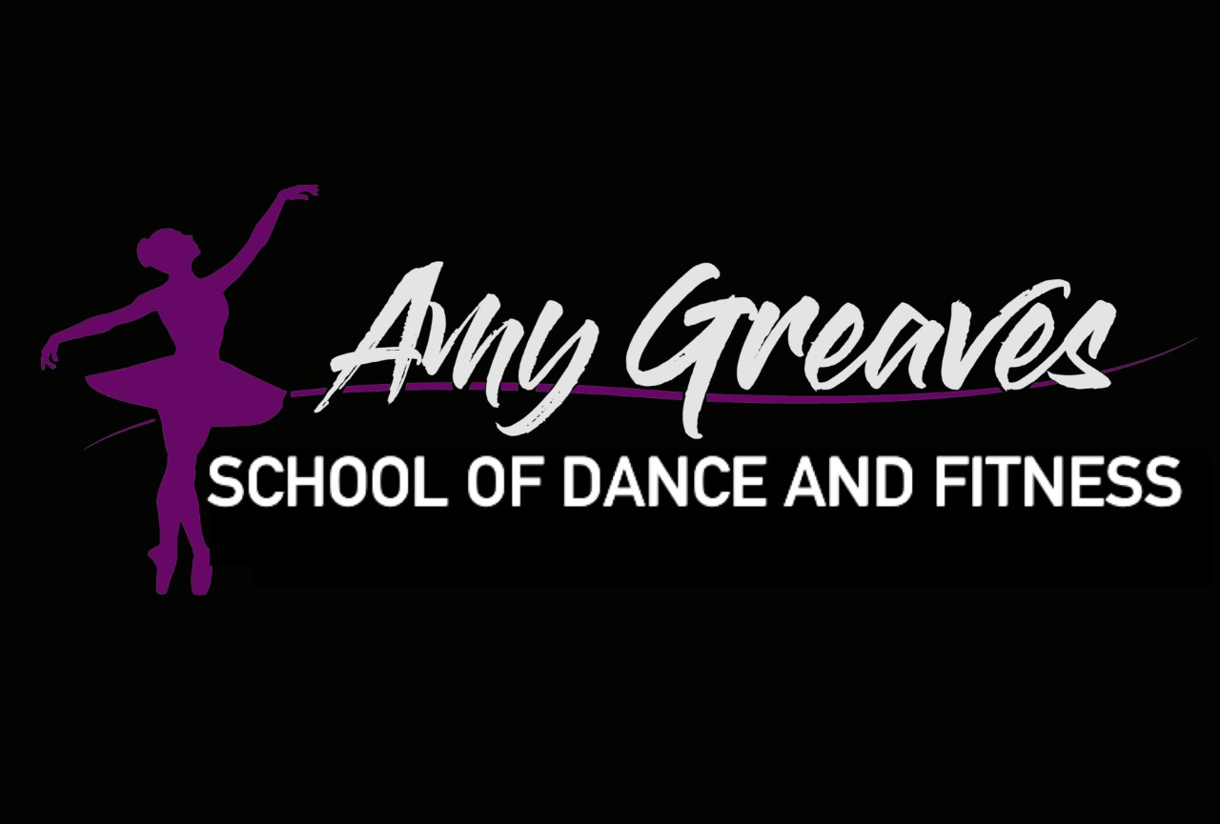
Amy Greaves School of Dance
Risk Assessment Policy 2024 V.1

Purpose
The Risk Assessment Policy is designed to identify, evaluate, and mitigate potential risks to ensure a safe environment for students, instructors, staff, and visitors at The Amy Greaves School of Dance. This policy outlines the procedures for conducting risk assessments to prevent accidents, injuries, and other hazards.

Scope
This policy applies to all activities, programs, facilities, and individuals associated with The Amy Greaves School of Dance.

Objectives
- To systematically identify potential hazards.
- To assess the likelihood and severity of risks.
- To implement measures to control or eliminate risks.
- To promote a culture of safety and risk awareness.

Definitions
- Risk Assessment: The process of identifying hazards, evaluating the risks associated with them, and determining appropriate measures to control the risks.
- Hazard: Anything with the potential to cause harm, such as physical, chemical, biological, ergonomic, and psychosocial factors.
- Risk: The likelihood that a hazard will cause harm and the severity of the resulting impact.

Procedures
- Responsibility
  - The Director of [Dance School Name] is responsible for ensuring that risk assessments are conducted and reviewed regularly.
  - Instructors, staff, and designated safety officers are responsible for participating in the risk assessment process and implementing control measures.
- Risk Assessment Process
  - Identify Hazards: List all potential hazards associated with dance school activities, including but not limited to:
    - Physical environment (e.g., flooring, lighting, equipment)
    - Dance activities (e.g., lifts, jumps, routines)
    - Health and safety (e.g., first aid, fire safety, allergies)
  - Evaluate Risks: Assess each identified hazard to determine:
    - The likelihood of the hazard occurring.
    - The potential severity of harm if the hazard occurs.
    - Use a risk matrix to categorize risks (e.g., low, medium, high).
  - Control Measures: Identify and implement measures to control risks, such as:
    - Removing the hazard where possible.
    - Substituting the hazard with something less dangerous.
    - Implementing engineering controls (e.g., safety equipment, barriers).
    - Adopting administrative controls (e.g., policies, training, signage).
    - Providing personal protective equipment (PPE) if necessary.
  - Record Findings: Document the risk assessment process, including identified hazards, risk evaluations, and control measures. Maintain records for future reference and regulatory compliance.
  - Review and Update: Regularly review and update risk assessments, especially when:
    - There are changes in activities, equipment, or facilities.
    - New hazards are identified.
    - Incidents or near-misses occur.
- Specific Areas of Risk Assessment
  - Facilities and Equipment
    - Regularly inspect dance floors, mirrors, barres, and other equipment for damage and hazards.
    - Ensure proper maintenance and repair of all facilities and equipment.
  - Dance Activities
    - Assess risks associated with different dance styles and routines.
    - Provide appropriate training and supervision for complex or high-risk activities.
  - Health and Safety
    - Maintain accessible first aid kits and train staff in first aid procedures.
    - Develop and practice emergency evacuation plans.
    - Address specific health concerns, such as allergies, medical conditions, and injury prevention.
- Communication and Training
  - Communicate risk assessment findings and control measures to all staff, instructors, and students.
  - Provide regular training on risk awareness, safety procedures, and emergency response.
- Incident Reporting and Investigation
  - Implement a system for reporting and investigating accidents, injuries, and near-misses.
  - Use incident reports to review and improve risk assessments and control measures.

Conclusion
Amy Greaves School of Dance is committed to providing a safe environment for all participants. Through systematic risk assessments and proactive safety measures, we aim to minimise risks and ensure the well-being of everyone involved in our programs.

For any questions or further clarification on the Risk Assessment Policy, please contact Amy Prior at 07979408997.

