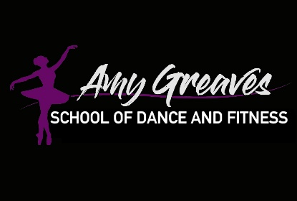
FAQ’s
1. What classes can I take?
Classes are broken down into age groups. If you visit the timetable on the school website you will be able to see the best classes for your age. However, if you need any help please contact Amy. http://www.amygreavesschoolofdance.com/Products.html

2. How much are classes?
If you’re a new member you can try one week for FREE. You can take as many classes as you like in this trial week.
After this classes are £3.70 per half an hour. £7.40 if you take the advanced one hour class. Classes are paid for in half term blocks (normally 6/7 weeks) via bank transfer. You will be invoiced for your classes in the last week of each half term.

3. Is there a uniform?
Yes after your settling in period. It is advised to purchase the uniform. It’s important to dance in the correct items to ensure you are safe and can perform the movements correctly. General uniform items I advise you purchasing online through your own google search. I place an order for AGSOD items at the start of each half term. To view prices and sizes please click blow:

http://www.amygreavesschoolofdance.com/Products.html

To place your order. Please email orders to agsoduniformorder@outlook.com and transfer payment.

4. Do you do exams & shows?
We do achievement awards with the i-PATH examination body. We have class recitals at Christmas and Easter. We have lots of other performance opportunities throughout the year.

5. Venue onformation
Thursday Class Venue Address:
- Rowheath Pavilion.
Heath Rd,
Birmingham
B30 1HH
Free parking

Saturday Class Venue Address: Birmingham Road
- Hopwood Village Hall
Hopwood
Birmingham
West Midlands
B48 7AL
There is free parking at this venue. However it is limited. If the parking is full you are allowed to park for free in the Westmead Hotel. Please do not park on The Rise, as this is a private road.

