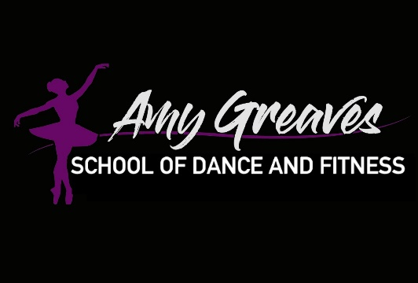

ACHIEVEMENT AWARD – ASSESSMENT CRITERIA

BALLET

TAP

COMMERCIAL

ACRO/CHEER

CONTEMPORARY

MUSICAL THEATRE

JAZZ

POINTE WORK

